Smart Communication Platform (SCP)
[Placeholder for list of reviewers]
[Placeholder for Table of Contents]

Introduction
Computershare provides a large portfolio of applications and systems for planning and conducting Annual General Meetings in the Central European market. These products contain services for Issuers, Shareholders, Banks, and other stakeholders, including internal operation units. Services are being made available to all stakeholders for paper based and online communication, as well as real-time services running at the AGM locations.

1.1 About this document [To be moved after table of contents]
This document covers the specification of broker-based messaging system that will be used as communication platform for services running in annual general meetings (AGMs).
Generally, preparation of the SRS has dependency to BRS and SAS. Due to the nature of messaging system, business may have not be able to define concrete business requirement in SCP but for sure SCP facilitates to meet business requirements with high degree of reliability.

1.2 Goals and Objectives
As more and more of these services are requested to be available online, on any device, at any time, CTS is preparing a new platform which binds all parts together: the Smart Communication Platform (SCP).
SCP facilitates the communication between Internet hosted applications and the several distributed highly-secured local networks at the AGM locations.
Currently, the plan is to develop SCP as general purpose communication platform to facilitate communications between existing services. However, the platform should be used for a wide range of applications that are addressed in Future work of this document.
- To be a reliable platform that does not miss any message.
- To be scalable so that it can adapt to various volume of messages.
- To be high performance so that the applications on top of SCP can meet their business requirement in a real-time manner.
- To be flexible to adapt to other OS and messaging systems with very minimal effort.
- To support wide range of requirements of the existing applications, and future applications as far as we can see at the time of preparing this document.
- To be secure so that it guarantees both Computershare and its Customers would be secured with very minimal chance of data leak or intrusion.
- To be available so that SCP is up and running and functions as it is planned.
To achieve the aforementioned objectives, the team investigated on advanced technologies, tools and users feedback from the companies that were pioneer to use them. The team also discussed with experts in Computershare to have their insights about tools and technologies for SCP.

1.3 Statement of scope

The focus of this document is on SCP core including the technologies, architectural design, and detailed design specifications. Because SCP should be used for wide range of applications in company, it is decoupled from any specific business requirement of applications. Instead SCP provides a flexible general purpose platform, so each service can only focus on its functionality and communicate to other services without getting involved to the logic of other services. The technologies that are within the scope of this document are:
- .Net Core
- Event driven architecture (EDA)
- Messaging System
  - Phase 1: Azure ServiceBus only
  - Future: any (like IBM MQ Websphere etc.)
- NServiceBus

1.4 Software context
Provided SCP, the services communicate through smart communication platform. Each service only focuses on its business logic and cannot send or receive data through a direct call to the service.

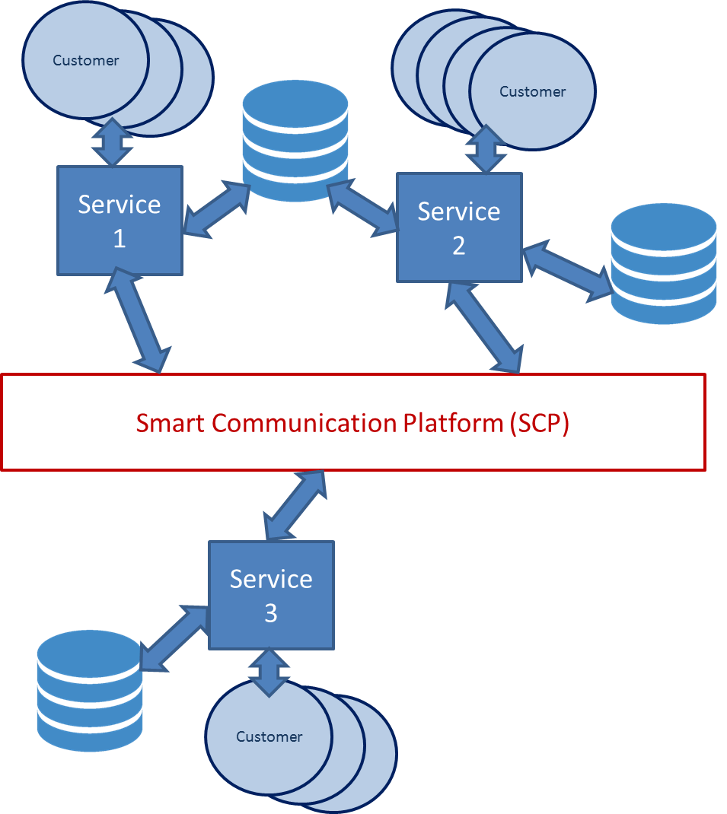

The diagram shows that SCP provides a centralized environment for the messaging among services; it manages the authorization of the services to access to the relevant messaging containers. SCP does not cover business logic in its implementation. The business logic with be kept in domain of microservices.

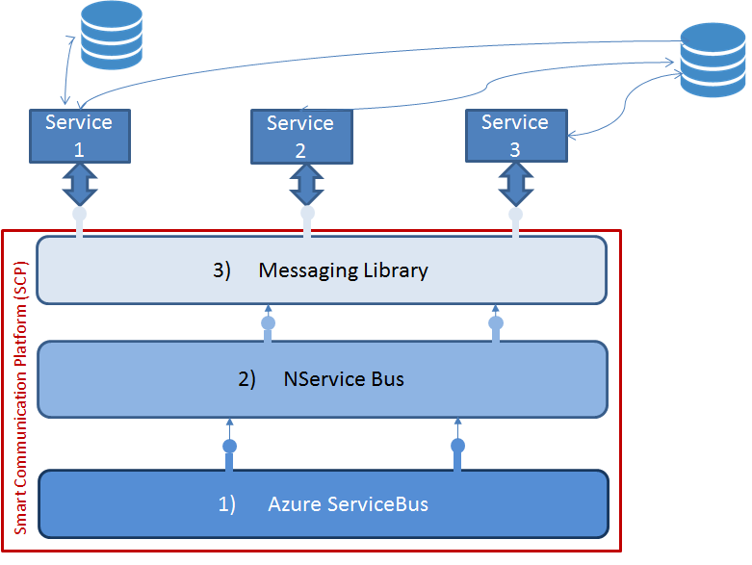
SCP is only exposed to the endpoints of the services through messaging library interfaces. NService Bus shields the internal components of Broker-based messaging systems, namely Azure ServiceBus, so the underneath layers have nothing to share about their internal processes with services. The decoupled layers facilitate adapting to new technologies and easily migration to new tools that may happen at in future.

1.5 Future work
At the time preparing this document the following applications are planned for development on top of SCP. The applications that are planned are not just limited to the below list.

1.5.1 SmartVoting
Enables shareholders to vote at the AGM using their own or CPU provided devices.

1.5.2 SmartInfo
Real-time information from AGM-based applications like HVWIN, HVQUEST, HVCHAT.

1.5.3 Quest NG
Unified communication for online experts.

1.5.4 Next Generation “OTP”
Making AGMs available online in real-time, smoothly integrated within InvestorPortal.

A couple of other applications based on streaming analytics and data analytics will be built on top of SCP the SCP platform developed and found reliable. These applications can bring immediate business value for Computershare.

1.6 Major constraints
Adapting to SCP does not impose a huge change on existing applications, just to adapt to send data to and receive data from other applications. A couple of legacy applications in Computershare might not be changed at the moment. During investigation phase, we found and planned some work arounds to keep these systems as they currently are. The plan is not to change SCP, neither the legacy applications, but is to provide a service that send/ receive data between the legacy application and the SCP. For instance, “HVWin SCP Bridge”.

2 Data design
The message conveys the data that different services use them for their internal processes. Some mandatory attributes should be populated in the message so once the message is the received by the service would know what to do with it. Messages may come from heterogeneous sources, which use different technologies, for different reasons, with different background processes, generated in different timestamps in different time zones and finally some contents that they convey in their bodies. Although SCP does not get involved with message bodies, it is likely to have some requirements that SCP filters the messages based on their headers.

Later, we may define different message structures based on internal, global, and temporary data. Some initial message attributes are listed here.
Message
- ID
- Type
- Tags
- Timestamp
- Sender (Origin)
- Body

3 Architectural and component-level design

3.1. Avoiding different forms of coupling
The architectural goal behind SCP is to avoid different forms of coupling including, platform, behavioral and temporal coupling. By avoiding platform coupling, different layers of SCP have no or at least very minimal dependency to specific technologies. In this regard, .Net Core can provide flexibility to deploy SCP on various operating systems. In addition, NServiceBus makes SCP flexible to switch to other broker-based messaging systems.
To isolate the system from behavioral coupling, SCP uses a Messaging Layer which decouples its functionality from the direct instantiation or name of methods it is calling. SCP comes with a set of interfaces to support dependency inversion.
Important note: At the time of preparing this document, we still have no NServiceBus license. It is likely to find overlap between Messaging Layer and NServiceBus layer in the current design. The design of Messaging Layer needs to be planned after having comprehensive knowledge about NServiceBus.
The SCP architecture avoids temporal coupling by employing Message Broker system in the 2nd layer of SCP, here is initially Azure ServiceBus. If for any reasons the receiving service is down, the unavailability of that faulty service does not affect the expected functionality of the other healthy services. This functionality of Message Broker system stemmed from event driven architecture (EDA). Provided EDA, SCP provides better availability through load balancing.
By avoiding platform, behavioral and temporal couplings, SCP provides a flexible messaging system. SCP also employed cutting edge technologies to guarantee the reliability and performance of messaging between different services.

3.2. Azure ServiceBus share some interfaces to share the results of its internal process to its immediate upper layer. Azure Service Bus has no dependency on changes on Message library layer. Message library can only use the exposed endpoints of Azure ServiceBus to get input. All brokered based messaging systems follow general specifications of Pub/Sub systems and have a standard behavior. For instance conceptual definition of Queue and Topic are universal. Within the Layer 2 of Figure .3, message broker products from different companies have different implementations but they expose very similar functionalities and interfaces.

3.2 Supporting legacy Applications while adapting new technologies

One of the advantages of developing SCP is to support legacy and new applications side by side. Currently, there are several business critical applications that are stable but they use some technologies are planned to sunset. For instance, CNG admin and investor portal use .Net Framework but Microsoft’s future direction is to go for .Net Core.

3.2.1. Employing .NET Standard
The .NET Standard is a formal specification of .NET APIs that are intended to be available on all .NET implementations. The reason behind the .NET Standard is establishing greater uniformity in the .NET ecosystem. Given in Computershare we have a set of applications on .Net Framework and some others are planned for .Net Core, can .Net Standard help to have one implementation?
“The .NET Standard enables the following key scenarios:
- Defines uniform set of BCL APIs for all .NET implementations to implement, independent of workload.
- Enables developers to produce portable libraries that are usable across .NET implementations, using this same set of APIs.
- Reduces or even eliminates conditional compilation of shared source due to .NET APIs, only for OS APIs.”
https://docs.microsoft.com/en-us/dotnet/standard/net-standard
Current implementations of CNG admin and investor portal use more than only BCLs. How .Net Standard APIs work with Entity framework, MVC or other features in figure 3.1?
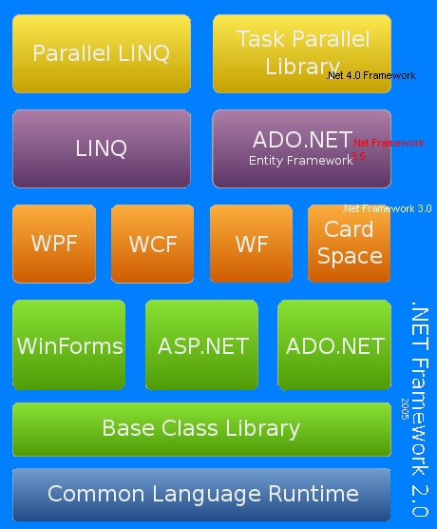
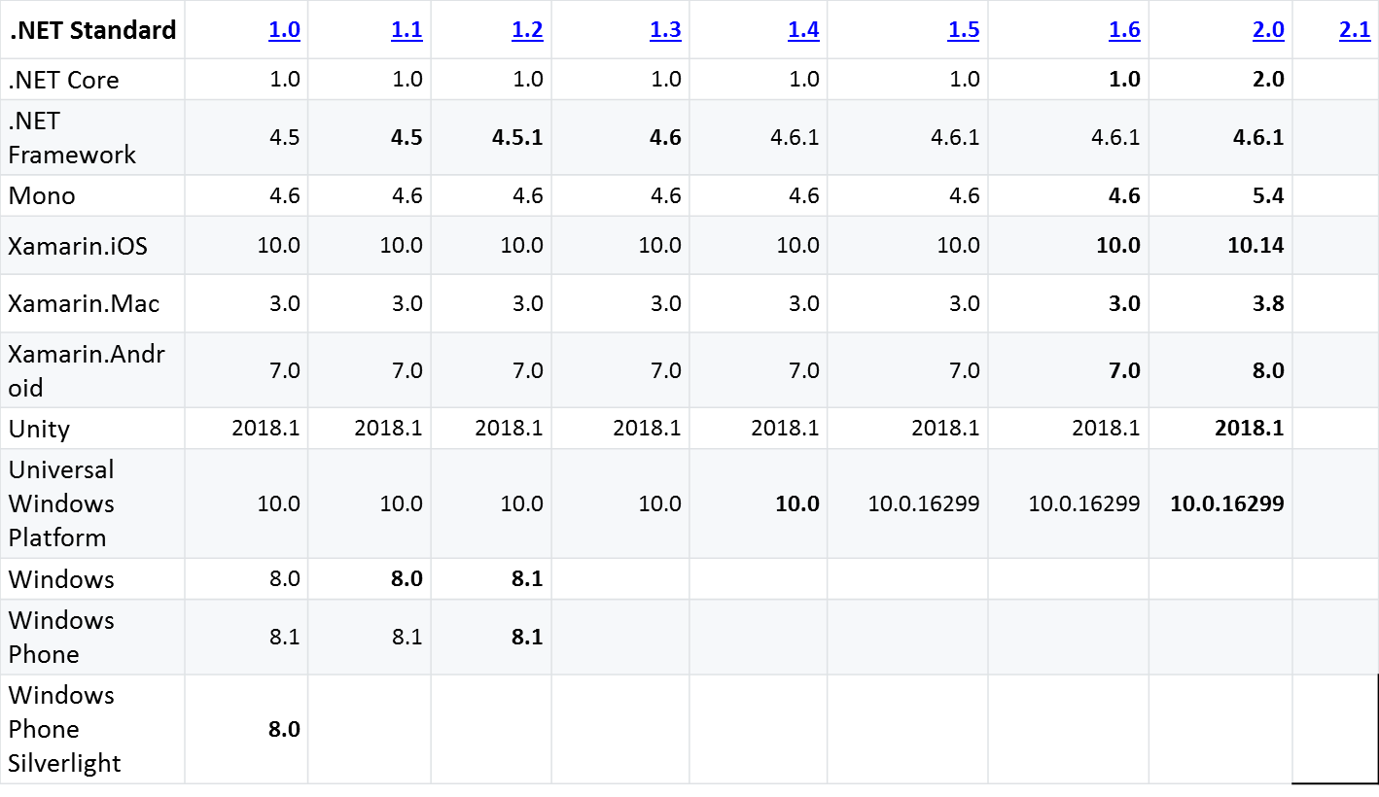
https://github.com/dotnet/standard/blob/master/docs/versions.md
It seems when we choose a .NET Standard version, a trade off should be considered:
- The higher the version, the more APIs are available.
- The lower the version, the more platforms implement it.

The .Net framework has some commonality with .Net core APIs but not everything is in .Net Standard is in shared APIs overlapped space. Here in Computershare, we have not much concern about the part that .Net Core API does not share with .Net Framework as we still have no application developed on .Net Core. But the green area which is not shared can cause issues when, the .Net Standard comes to the picture.
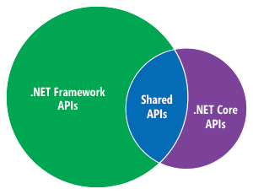
Figure courtesy [7]

https://msdn.microsoft.com/en-us/magazine/mt694084.aspx

A detailed description the system structure chosen for the application is presented.

3.2.2 Architecture diagram
A pictorial representation, using a UML component diagram, of the architecture is presented.

3.2 Description for Component n
A detailed description of each software component contained within the architecture is presented. Section 3.2 is repeated for each of n components.
3.2.1 Processing narrative (PSPEC) for component n
A processing narrative for component n is presented. It should describe the responsibilities of the component.
3.2.2 Component n interface description.
A detailed description of the input and output interfaces for the component is presented.
3.2.3 Component n processing detail
A detailed algorithmic description for each component is presented.
3.2.3.1 Design Class hierarchy for component n
3.2.3.2 Restrictions/limitations for component n
3.2.3.3 Performance issues for component n
3.2.3.4 Design constraints for component n
3.2.3.5 Processing detail for each operation of component n
3.2.3.5.1 Processing narrative (PSPEC) for each operation
3.2.3.5.2 Algorithmic model (e.g., PDL) for each operation

3.3 Dynamic Behavior for Component n
A description of the interaction of the classes is presented.
3.3.1 Interaction Diagrams
A sequence diagram, for each use case the component realizes, is presented.
3.2 Description for Component n
A detailed description of each software component contained within the architecture is presented. Section 3.2 is repeated for each of n components.
3.2.1 Processing narrative (PSPEC) for component n
A processing narrative for component n is presented. It should describe the responsibilities of the component.
3.2.2 Component n interface description.
A detailed description of the input and output interfaces for the component is presented.
3.2.3 Component n processing detail
A detailed algorithmic description for each component is presented.
3.2.3.1 Design Class hierarchy for component n
3.2.3.2 Restrictions/limitations for component n
3.2.3.3 Performance issues for component n
3.2.3.4 Design constraints for component n
3.2.3.5 Processing detail for each operation of component n
3.2.3.5.1 Processing narrative (PSPEC) for each operation
3.2.3.5.2 Algorithmic model (e.g., PDL) for each operation
3.3 Dynamic Behavior for Component n
A description of the interaction of the classes is presented.
3.3.1 Interaction Diagrams
A sequence diagram, for each use case the component realizes, is presented.

0.0 Revision History and Table of Content
1.0 Introduction
This section provides an overview of the entire requirement document. This document describes all data, functional and behavioral requirements for software.
1.1 Goals and objectives
Overall goals and software objectives are described.
1.2 Statement of scope
A description of the software is presented. Major inputs, processing functionality and outputs are described without regards to implementation detail. Rank the major processing functionality from the developer's point of view. Use a simple ranking system such as: essential, desirable and future requirements. This should represent what you think your team can accomplish in the time frame of a semester. The essential requirements, you are sure you can complete. The desirable requirements you hope to complete, but are not sure about. The future requirements, you have strong doubts about. Strive to balance the desires of your client with the reality of the time it takes to develop a SW product.
1.3 Software context
The software is placed in a business or product line context. Strategic issues relevant to context are discussed. The intent is for the reader to understand the 'big picture'.
1.4 Major constraints
Any business or product line constraints that will impact the manner in which the software is to be specified, designed, implemented or tested are noted here.

- Data design

A description of all data structures including internal, global, and temporary data structures.
2.1 Internal software data structure
Data structures that are passed among components of the software are described.
2.2 Global data structure
Data structured that are available to major portions of the architecture are described.
2.3 Temporary data structure
Files created for interim use are described.
2.4 Database description
Database(s) created as part of the application is(are) described. (Provide enough detail to create the database.)
3.0 Architectural and component-level design
A description of the program architecture is presented.
3.1 System Structure
A detailed description the system structure chosen for the application is presented.
3.1.1 Architecture diagram
A pictorial representation, using a UML component diagram, of the architecture is presented.
3.2 Description for Component n
A detailed description of each software component contained within the architecture is presented. Section 3.2 is repeated for each of n components.
3.2.1 Processing narrative (PSPEC) for component n
A processing narrative for component n is presented. It should describe the responsibilities of the component.
3.2.2 Component n interface description.
A detailed description of the input and output interfaces for the component is presented.
3.2.3 Component n processing detail
A detailed algorithmic description for each component is presented.
3.2.3.1 Design Class hierarchy for component n
3.2.3.2 Restrictions/limitations for component n
3.2.3.3 Performance issues for component n
3.2.3.4 Design constraints for component n
3.2.3.5 Processing detail for each operation of component n
3.2.3.5.1 Processing narrative (PSPEC) for each operation
3.2.3.5.2 Algorithmic model (e.g., PDL) for each operation
3.3 Dynamic Behavior for Component n
A description of the interaction of the classes is presented.
3.3.1 Interaction Diagrams
A sequence diagram, for each use case the component realizes, is presented.

4.0 User interface design
A description of the user interface design of the software is presented.
4.1 Description of the user interface
A detailed description of user interface including screen images or prototype is presented.
4.1.1 Screen images
Representation of the interface form the user's point of view.
4.1.2 Objects and actions
All screen objects and actions are identified.
4.2 Interface design rules
Conventions and standards used for designing/implementing the user interface are stated. (You could list the eight golden rules mentioned in lecture.)
4.3 Components available
GUI components available for implementation are noted.
4.4 UIDS description
The user interface development system is described. (You might not have one for your project.)
5.0 Restrictions, limitations, and constraints
Special design issues which impact the design or implementation of the software are noted here.
6.0 Testing Issues
Test strategy and preliminary test case specification are presented in this section.
6.1 Classes of tests
The types of tests to be conducted are specified, including as much detail as is possible at this stage. Emphasis here is on black-box and white-box testing.
6.2 Expected software response
The expected results from testing are specified.
6.3 Performance bounds
Special performance requirements are specified.
6.4 Identification of critical components
Those components that are critical and demand particular attention during testing are identified.
7.0 Appendix
8.0 References

